**EX.NO:8 REGISTER NO:210701307**

**DATE:**

**IMPLEMENT SVM/DECISION TREE CLASSIFICATION TECHNIQUES**

**AIM:**

To implement SVM/Decision tree classification techniques.

**PROGRAMCODE:**

**SVM IN R:**

#Install and load the e1071 package(ifnotalreadyinstalled) install.packages("e1071") library(e1071) #Load the iris dataset

data(iris)

#Inspect the first few rows of the dataset head(iris)

#Split the data into training(70%) and testing(30%)sets set.seed(123) # For reproducibility

sample_indices<-sample(1:nrow(iris),0.7*nrow(iris)) train_data

<- iris[sample_indices, ]

test_data<-iris[-sample_indices,] # Fit the SVM model

svm_model<-svm(Species~.,data=train_data,kernel="radial") #

Print the summary of the model summary(svm_model)

# Predict the test set

predictions<-predict(svm_model,newdata=test_data) # Evaluate the model's performance

confusion_matrix<-table(Predicted=predictions,Actual=test_data$Species) print(confusion_matrix)

#Calculate accuracy

accuracy<-sum(diag(confusion_matrix))/sum(confusion_matrix)

cat("Accuracy:", accuracy * 100, "%\n") **Decision tree in R:**

#Install and load the r part package(if not already installed) install.packages("rpart") library(rpart)

#Load the iris dataset

data(iris)

#Split the data into training(70%)and testing(30%)sets set.seed(123) # For reproducibility

sample_indices<-sample(1:nrow(iris),0.7*nrow(iris)) train_data

<- iris[sample_indices, ]

test_data<-iris[-sample_indices,] # Fit the Decision Tree model

tree_model<-rpart(Species ~., data=train_data,method="class")

#Print the summary of the model

summary(tree_model) # Plot the Decision Tree plot(tree_model)

text(tree_model,pretty=0) # Predict the test set

predictions<-predict(tree_model,newdata=test_data,type="class") # Evaluate the model's performance

confusion_matrix<-table(Predicted=predictions,Actual=test_data$Species) print(confusion_matrix)

#Calculateaccuracy

accuracy<-sum(diag(confusion_matrix))/sum(confusion_matrix) cat("Accuracy:", accuracy * 100, "%\n")

**OUTPUT:**

**SVM in R:**

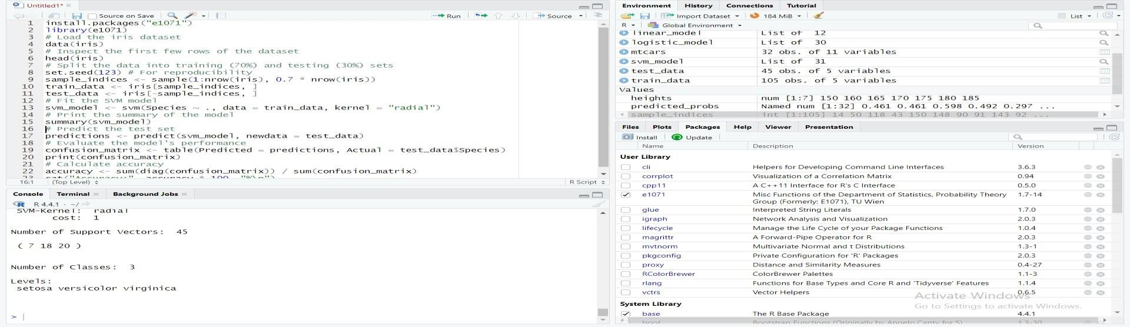

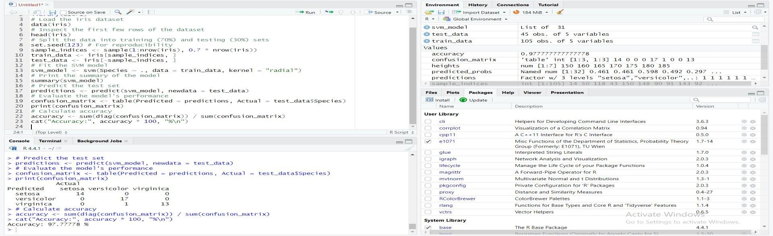

**Decision Tree in R:**

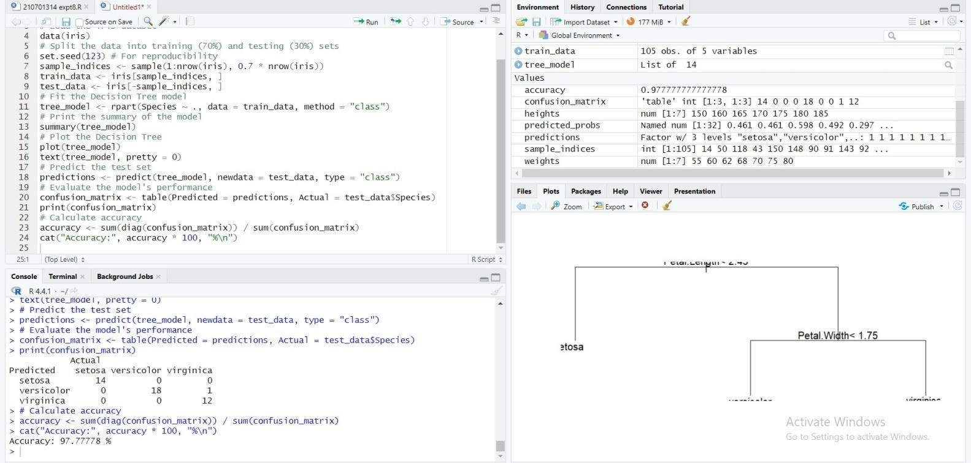

**RESULT:**

Thus the implementation of SVM/Decision tree classification techniques done successfully.